PRACTICAL 11

Deploy Nginx using Docker and Kubernetes
A hands-on lab for learning Docker containers and Kubernetes Deployments, Pods, and Services.

Student details
Field | Details
Name | Vaishnavi Shirke__________________________
Roll No. / ID | MCA-2504097______________________________
Batch / Section | MCA-B______________________________
Date performed | 17-09-2026______________________________

Learning objectives
By the end of this practical, you should be able to explain and demonstrate:
- What a Kubernetes cluster is
- What a Node is
- What a Pod is
- What a Deployment is
- What a Service is
- How Kubernetes uses Docker / container images
- How to deploy an application on Kubernetes
- How to scale an application
- How to check application logs
- How to delete Kubernetes resources

Before you start
Don't start with Kubernetes YAML, AKS, Helm, Ingress, Terraform, or Jenkins yet. This first practical is done entirely with docker and kubectl commands. Practical 2 will build your own image, push it to Docker Hub, and deploy it with a YAML Deployment and Service — that's where Docker and Kubernetes really connect.

Contents
(Right-click below and choose "Update Field" in Word to generate page numbers.)
Student details 1
Learning objectives 1
Before you start 1
Contents 1
Part A — Check Docker 1
Step A1: Start Docker Desktop 1
Step A2: Check the Docker version 1
Step A3: Check running containers 1
Part B — Enable Kubernetes 1
Part C — Check Kubernetes 1
Step C1: Check the kubectl version 1
Step C2: Check cluster nodes 1
Part D — Understand what you just created 1
Docker vs. Kubernetes 1
Part E — Download the Nginx Docker image 1
Step E1: Pull the Nginx image 1
Step E2: Confirm the image was downloaded 1
Part F — Run Nginx using Docker 1
Step F1: Run the Nginx container 1
Step F2: Confirm the container is running 1
Step F3: View Nginx in the browser 1
Part G — Stop the Docker container 1
Step G1: Stop the container 1
Step G2: Remove the container 1
Step G3: Confirm it's gone 1
Part H — Deploy Nginx using Kubernetes 1
Step H1: Create the Deployment 1
Part I — Check the Deployment 1
Step I1: List Deployments 1
Part J — Check the Pod 1
Step J1: List Pods 1
Part K — Understand Deployment and Pod 1
Part L — See the Pod details 1
Step L1: Describe the Pod 1
Step L2: Get extended Pod info 1
Part M — Check Nginx logs 1
Step M1: View Pod logs 1
Part N — Our application is NOT accessible yet 1
Part O — Create a Kubernetes Service 1
Step O1: Expose the Deployment 1
Step O2: List Services 1
Part P — Access Nginx 1
Step P1: Check the Service 1
Step P2: Port-forward to the Service 1
Step P3: Open Nginx in the browser 1
Part Q — The most important experiment: scaling 1
Step Q1: Scale the Deployment to 3 replicas 1
Step Q2: Confirm 3 Pods are running 1
Part R — Check the Deployment again 1
Step R1: List the Deployment 1
Part S — Test Kubernetes self-healing 1
Step S1: List Pods and copy one Pod name 1
Step S2: Delete that Pod 1
Step S3: Immediately check Pods again 1
Step S4: Check again after a few seconds 1
Part T — View everything together 1
Step T1: List all resources 1
Part U — Understand ReplicaSet 1
Part V — Inspect the Service 1
Step V1: Describe the Service 1
Part W — Clean up 1
Step W1: Delete the Service 1
Step W2: Delete the Deployment 1
Step W3: Confirm everything is gone 1
What you should understand after Practical 1 1
Appendix — Full command list (lab notebook copy) 1
Submission checklist 1

Part A — Check Docker

Step A1: Start Docker Desktop
Open Docker Desktop and make sure it is running (the whale icon should be steady, not animating).
📷 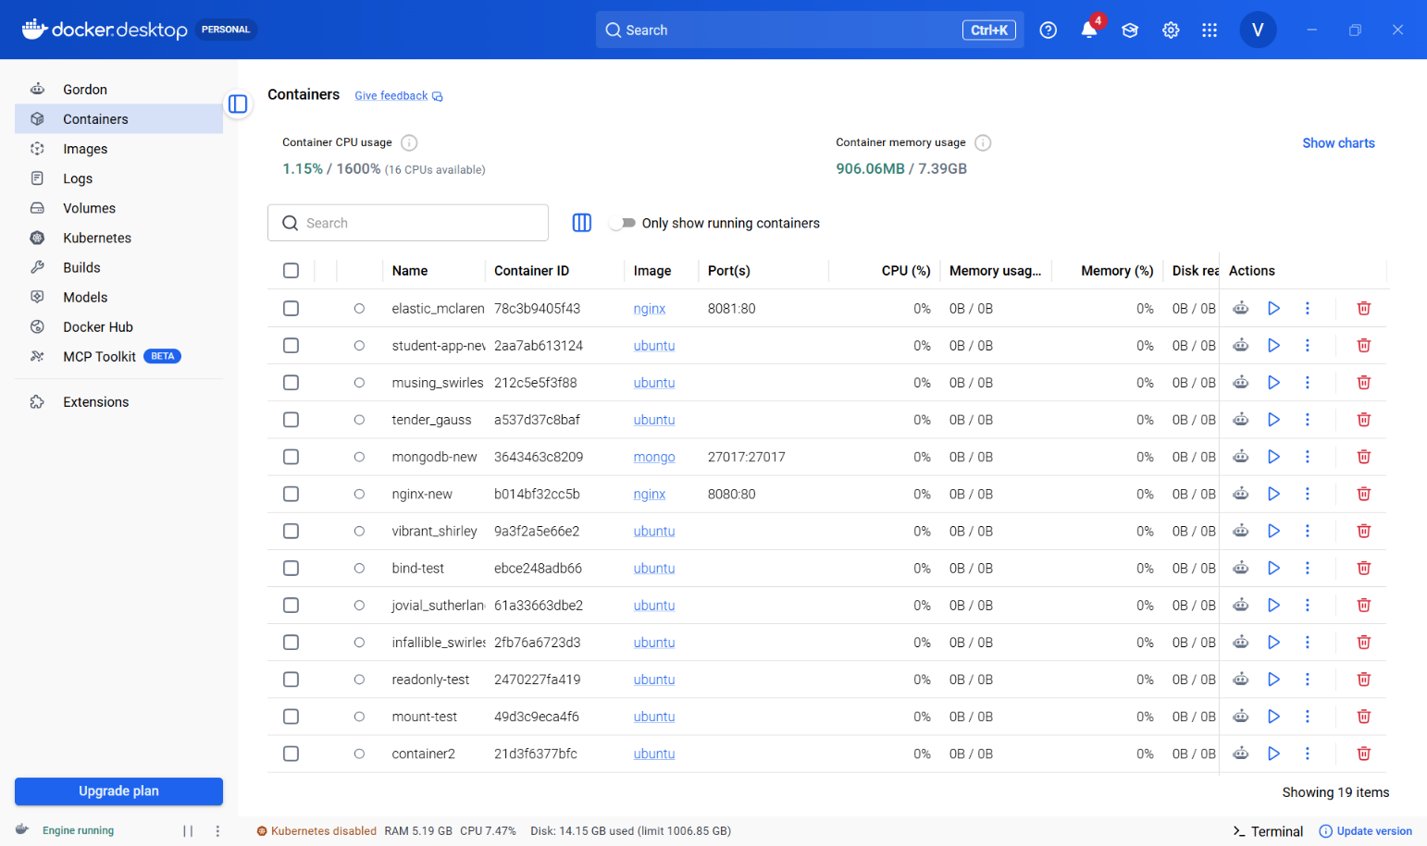INSERT SCREENSHOT HERE
Docker Desktop open and running

Step A2: Check the Docker version
Open Command Prompt or PowerShell and check that Docker is installed correctly.
Run:
docker --version

Expected output:
Docker version 28.x.x

Step A3: Check running containers
It is okay if the list is empty — you just want to confirm the command works.
Run:
docker ps

Expected output:
CONTAINER ID IMAGE COMMAND CREATED STATUS PORTS NAMES

📷 I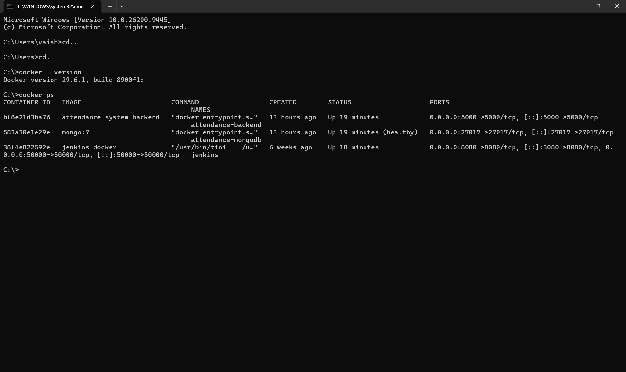NSERT SCREENSHOT HERE
Output of `docker ps` in your terminal

Part B — Enable Kubernetes
In a recent Docker Desktop version: go to Docker Desktop → Kubernetes → Create cluster. Docker Desktop supports local clusters using kubeadm or kind — for this practical, a single-node kubeadm cluster is enough.
In the older interface, instead go to Settings → Kubernetes → Enable Kubernetes, then let Docker Desktop start the cluster.
Wait until Docker Desktop shows the cluster as running before continuing.
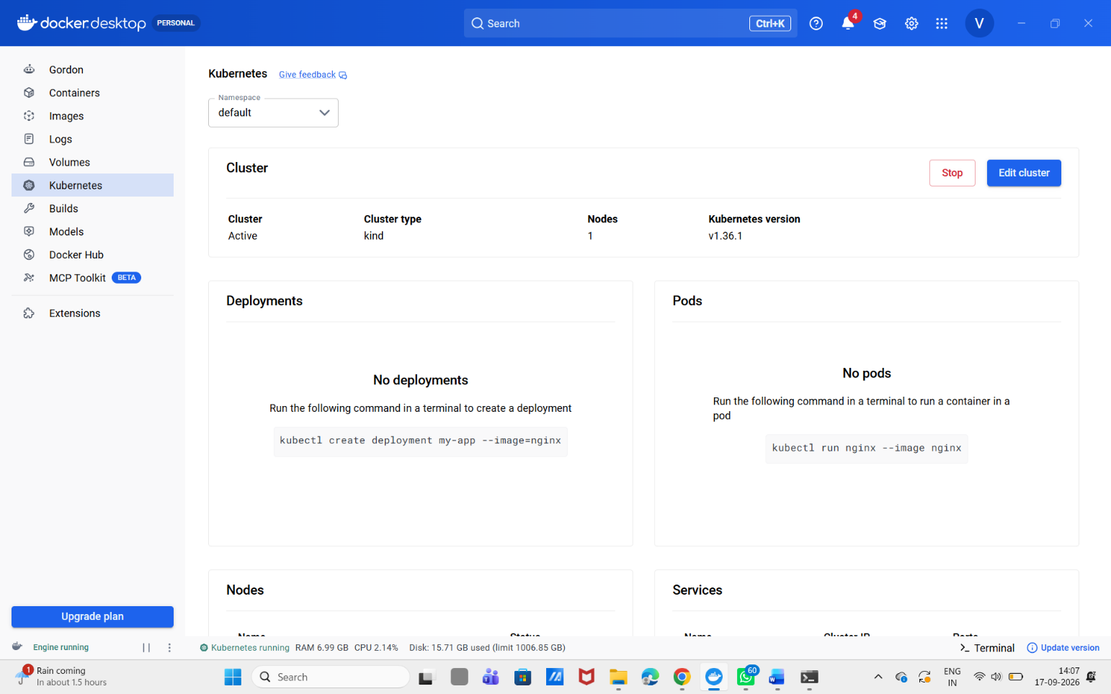📷 INSERT SCREENSHOT HERE
Docker Desktop → Kubernetes settings showing the cluster running

Part C — Check Kubernetes

Step C1: Check the kubectl version
Run:
kubectl version

Step C2: Check cluster nodes
The important word to look for is Ready.
Run:
kubectl get nodes

Expected output:
NAME STATUS ROLES AGE VERSION
docker-desktop Ready control-plane ... v1.xx.x

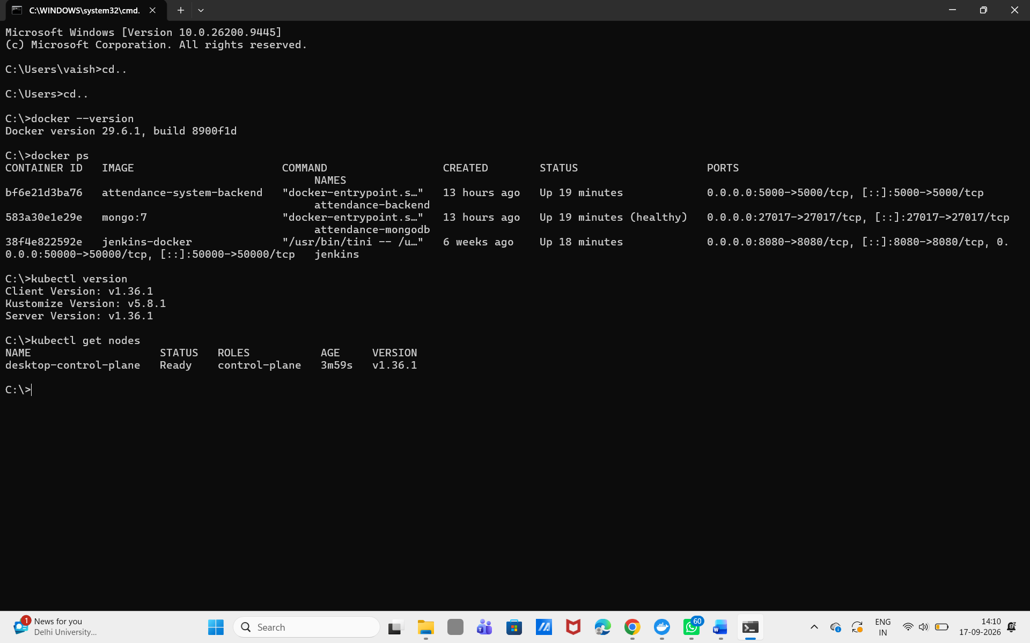 📷 INSERT SCREENSHOT HERE
Output of `kubectl get nodes` showing STATUS = Ready

If you see Ready, congratulations — you have your first working Kubernetes cluster.

Part D — Understand what you just created
Before doing the practical, understand the layers involved:
Your Computer
|
v
Docker Desktop
|
v
Kubernetes Cluster
|
v
Node
|
v
Pod
|
v
Nginx Container

Docker vs. Kubernetes
Docker — you directly start a container:
docker run nginx

Kubernetes — you declare intent, and Kubernetes creates and manages the Pods/containers for you:
Deployment
|
v
Pod
|
v
Nginx Container
A Kubernetes Deployment manages Pods and can restart them if necessary; Deployments are also used for scaling applications.

Part E — Download the Nginx Docker image

Step E1: Pull the Nginx image
We'll use Docker directly first, before bringing Kubernetes in.
Run:
docker pull nginx

Step E2: Confirm the image was downloaded
Run:
docker images

Expected output:
REPOSITORY TAG IMAGE ID CREATED SIZE
nginx latest xxxxxxxxxxxx ... ...

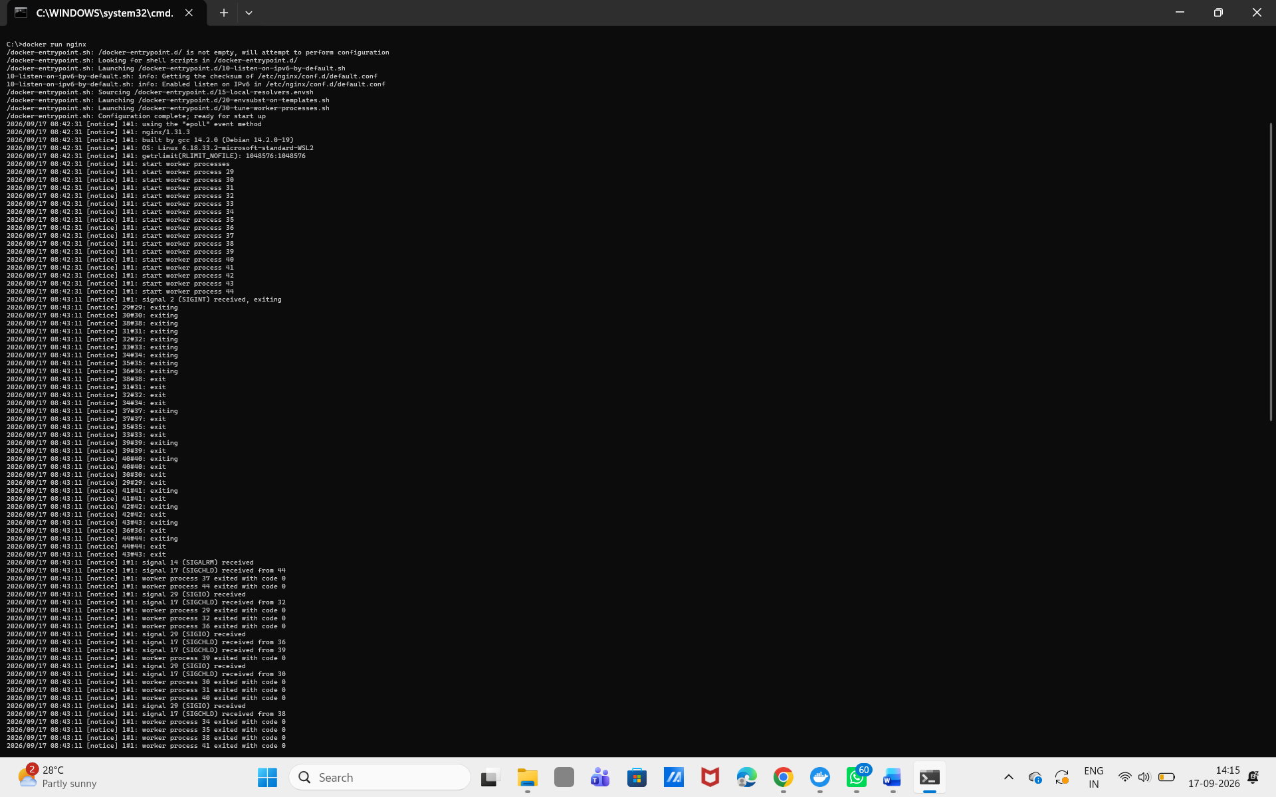 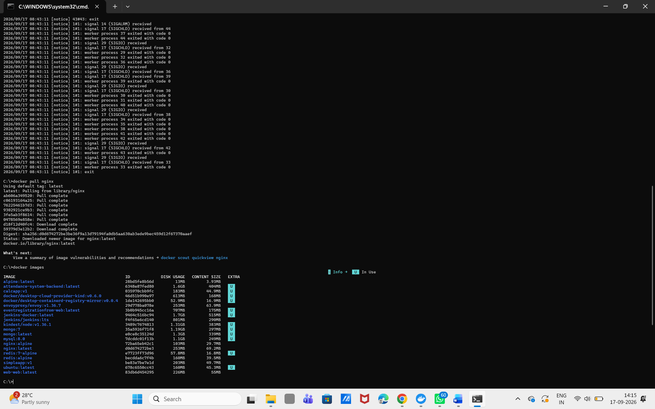 📷 INSERT SCREENSHOT HERE
Output of `docker images` showing nginx:latest

Part F — Run Nginx using Docker

Step F1: Run the Nginx container
Understand the command before running it:
docker run — create a container
-d — run in the background
--name my-nginx — name the container my-nginx
-p 8080:80 — map computer port 8080 to container port 80
nginx — the Docker image to use
Run:
docker run -d --name my-nginx -p 8080:80 nginx

Step F2: Confirm the container is running
Run:
docker ps

Expected output:
... my-nginx ...

Step F3: View Nginx in the browser
Open your browser and go to the URL below. You should see the default Nginx welcome page.
Run:
http://localhost:8080

Expected output:
Welcome to nginx!

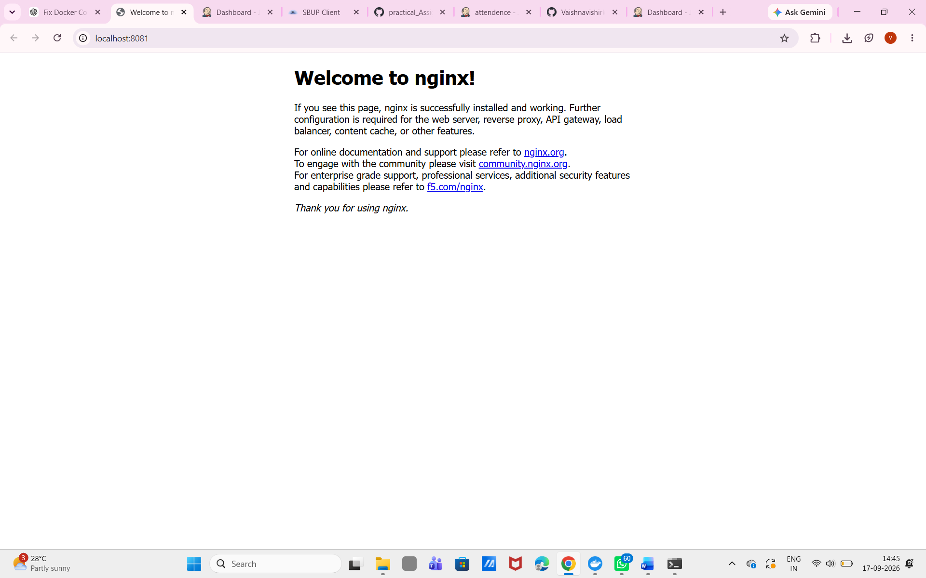📷 INSERT SCREENSHOT HERE
Browser showing the Nginx welcome page at localhost:8080

You have just deployed Nginx using Docker.

Part G — Stop the Docker container
We don't need this Docker container anymore because Kubernetes will run Nginx from here on.

Step G1: Stop the container
Run:
docker stop my-nginx

Step G2: Remove the container
Run:
docker rm my-nginx

Step G3: Confirm it's gone
Run:
docker ps

Expected output:
(my-nginx should no longer appear)

Part H — Deploy Nginx using Kubernetes
This is the important part of the practical.

Step H1: Create the Deployment
Run:
kubectl create deployment nginx --image=nginx

Expected output:
deployment.apps/nginx created

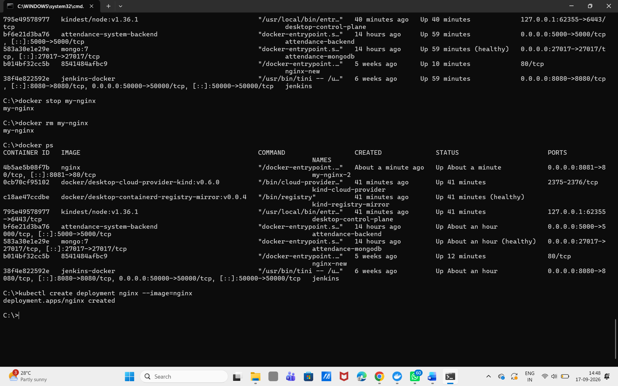

You have now created your first Kubernetes Deployment.

Part I — Check the Deployment

Step I1: List Deployments
This means Kubernetes wants 1 Pod, and currently has 1 Pod running.
Run:
kubectl get deployments

Expected output:
NAME READY UP-TO-DATE AVAILABLE
nginx 1/1 1 1

Part J — Check the Pod

Step J1: List Pods
The random-looking name (e.g. nginx-7c79c4bf97-abcde) is normal — Kubernetes generated it. Don't worry about memorizing it.
Run:
kubectl get pods

Expected output:
NAME READY STATUS RESTARTS AGE
nginx-xxxxxxxxxx-xxxxx 1/1 Running 0 30s

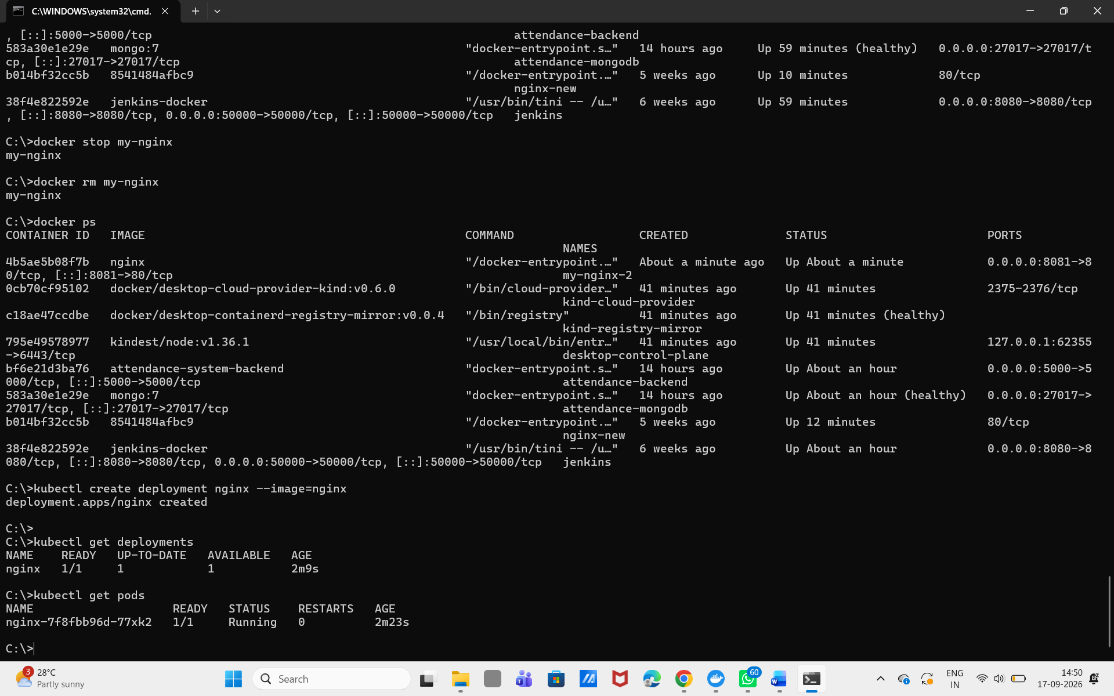 📷 INSERT SCREENSHOT HERE
Output of `kubectl get pods` showing STATUS = Running

Part K — Understand Deployment and Pod
You now have the following chain of objects:
Kubernetes
|
v
Deployment: nginx
|
v
Pod
|
v
Nginx Container
|
v
Port 80
Object | Meaning
Deployment | Controls the desired number of Pods.
Pod | The basic execution unit in Kubernetes.
Container | Your actual application runs inside the container.

Part L — See the Pod details

Step L1: Describe the Pod
Replace <POD_NAME> with the name you saw in Part J, e.g. nginx-7c79c4bf97-abcde. Look for the Containers: section in the output.
Run:
kubectl describe pod <POD_NAME>

# example:
kubectl describe pod nginx-7c79c4bf97-abcde

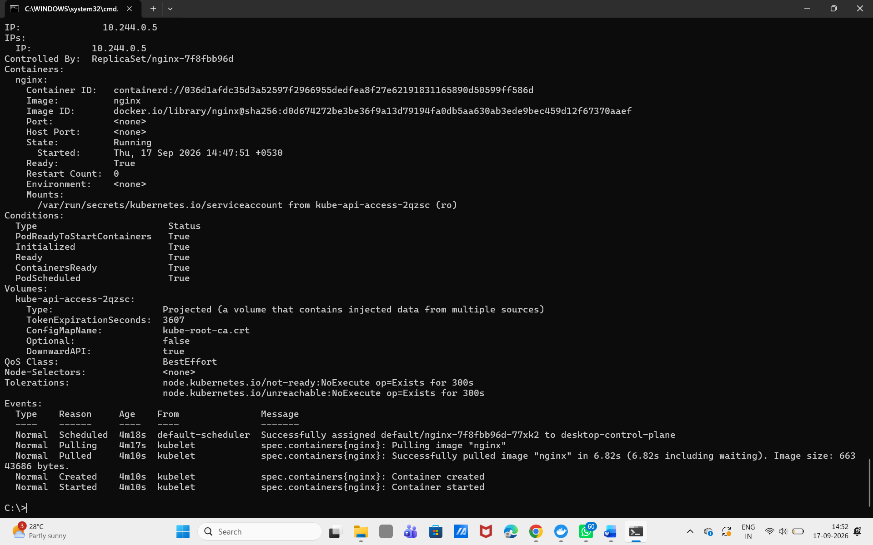 📷 INSERT SCREENSHOT HERE
Relevant section of `kubectl describe pod` output (Containers:)

Step L2: Get extended Pod info
Run:
kubectl get pods -o wide

Part M — Check Nginx logs

Step M1: View Pod logs
Run:
kubectl logs <POD_NAME>

# example:
kubectl logs nginx-7c79c4bf97-abcde

This is the Kubernetes equivalent of the Docker command:
docker logs my-nginx (Docker)
kubectl logs <POD_NAME> (Kubernetes)

Part N — Our application is NOT accessible yet
You created Deployment → Pod → Nginx, but if you try http://localhost you should not expect your Kubernetes Nginx to automatically appear there.
Why? Because the Pod only has an internal Kubernetes network address. We need a Service to expose it.

Part O — Create a Kubernetes Service

Step O1: Expose the Deployment
Run:
kubectl expose deployment nginx --type=NodePort --port=80

Expected output:
service/nginx exposed

Step O2: List Services
The important part is the port mapping, e.g. 80:30080/TCP. Your exact NodePort will differ.
Run:
kubectl get services

Expected output:
NAME TYPE CLUSTER-IP EXTERNAL-IP PORT(S)
kubernetes ClusterIP 10.x.x.x <none> 443/TCP
nginx NodePort 10.x.x.x <none> 80:30xxx/TCP

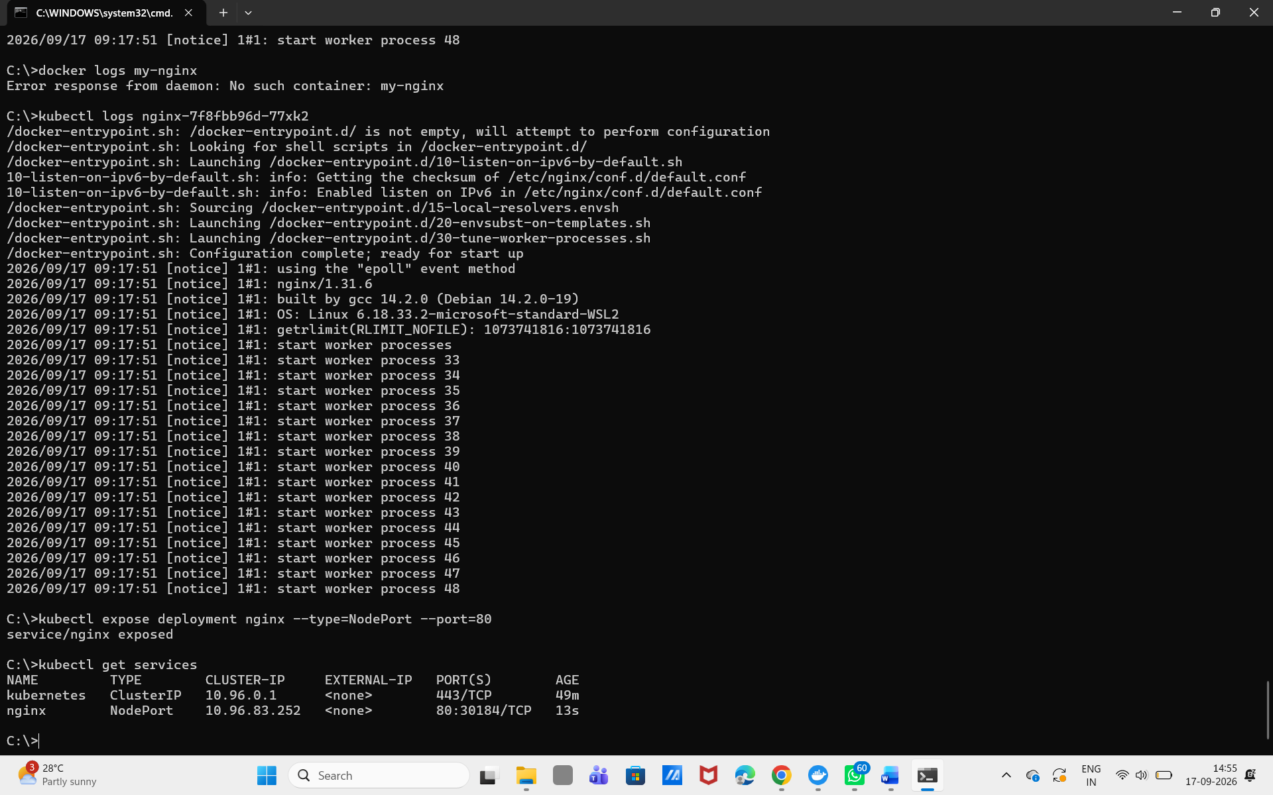📷 INSERT SCREENSHOT HERE
Output of `kubectl get services` showing the nginx NodePort

Part P — Access Nginx
Because you're using Docker Desktop Kubernetes, exactly how the Service is reachable can depend on your cluster setup.

Step P1: Check the Service
Run:
kubectl get service nginx

Step P2: Port-forward to the Service
This is the most reliable way to reach the Service from Docker Desktop. Keep this terminal running.
Run:
kubectl port-forward service/nginx 8080:80

Expected output:
Forwarding from 127.0.0.1:8080 -> 80

Step P3: Open Nginx in the browser
Run:
http://localhost:8080

Expected output:
Welcome to nginx!

You have now completed the full chain:
Docker Image
|
v
Kubernetes Deployment
|
v
Pod
|
v
Nginx Container
|
v
Kubernetes Service
|
v
Your Browser

Part Q — The most important experiment: scaling
Currently you have one Pod behind the Deployment:
nginx Deployment
|
v
Pod 1

Step Q1: Scale the Deployment to 3 replicas
Run:
kubectl scale deployment nginx --replicas=3

Expected output:
deployment.apps/nginx scaled

Step Q2: Confirm 3 Pods are running
Run:
kubectl get pods

Expected output:
NAME READY STATUS RESTARTS
nginx-xxxxx-aaaaa 1/1 Running 0
nginx-xxxxx-bbbbb 1/1 Running 0
nginx-xxxxx-ccccc 1/1 Running 0

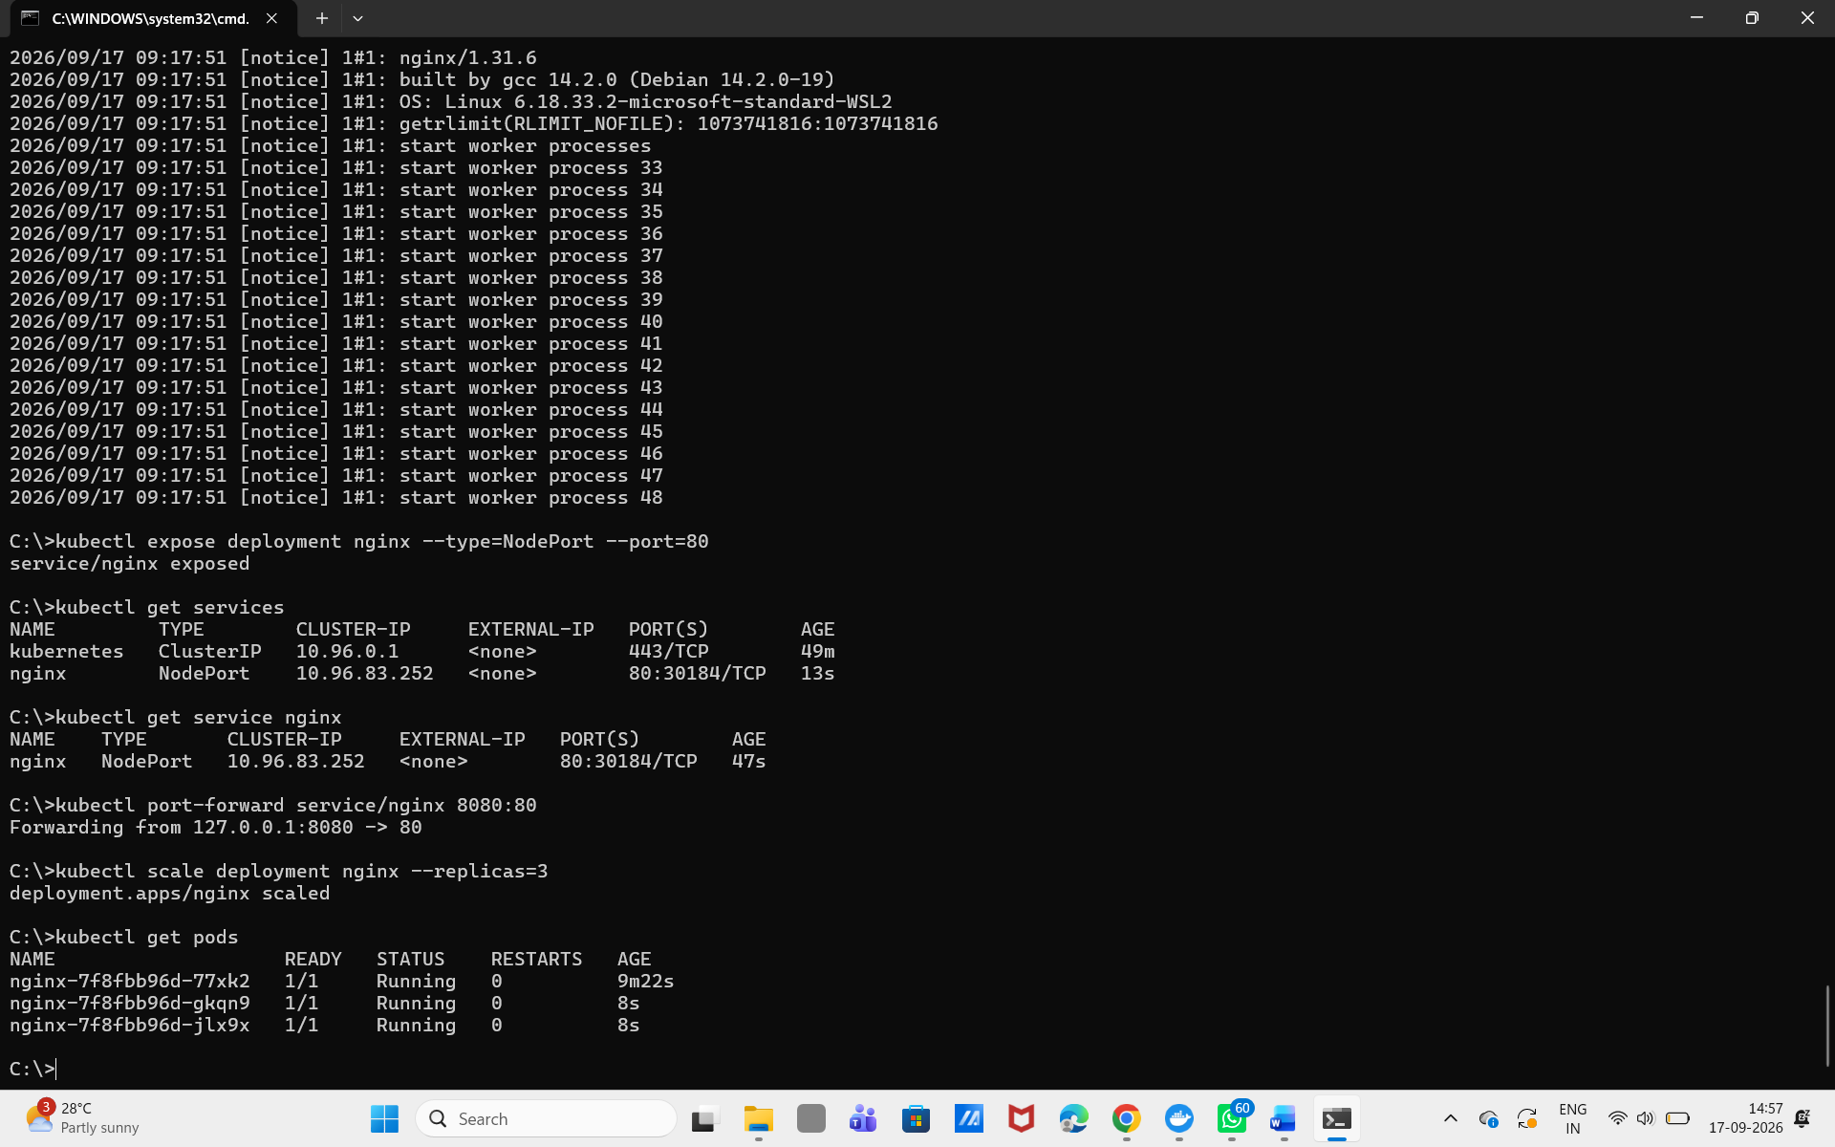 📷 INSERT SCREENSHOT HERE
Output of `kubectl get pods` showing 3 Running Pods

You now have:
Deployment
|
+----------+----------+
| | |
v v v
Pod 1 Pod 2 Pod 3
| | |
v v v
Nginx Nginx Nginx
This is one of the fundamental ideas behind Kubernetes.

Part R — Check the Deployment again

Step R1: List the Deployment
3/3 means three Pods are ready out of three desired Pods.
Run:
kubectl get deployment

Expected output:
NAME READY UP-TO-DATE AVAILABLE
nginx 3/3 3 3

Part S — Test Kubernetes self-healing

Step S1: List Pods and copy one Pod name
Run:
kubectl get pods

Expected output:
(copy one Pod name, e.g. nginx-xxxxx-aaaaa)

Step S2: Delete that Pod
You might think your application is now down.
Run:
kubectl delete pod nginx-xxxxx-aaaaa

Step S3: Immediately check Pods again
You may see a new Pod already being created.
Run:
kubectl get pods

Step S4: Check again after a few seconds
You should eventually be back to 3 Pods. Because you told Kubernetes "I want 3 replicas", when it sees Desired = 3 but Actual = 2, it creates another Pod. This is the beginning of self-healing.
Run:
kubectl get pods

Expected output:
(3 Pods Running again)

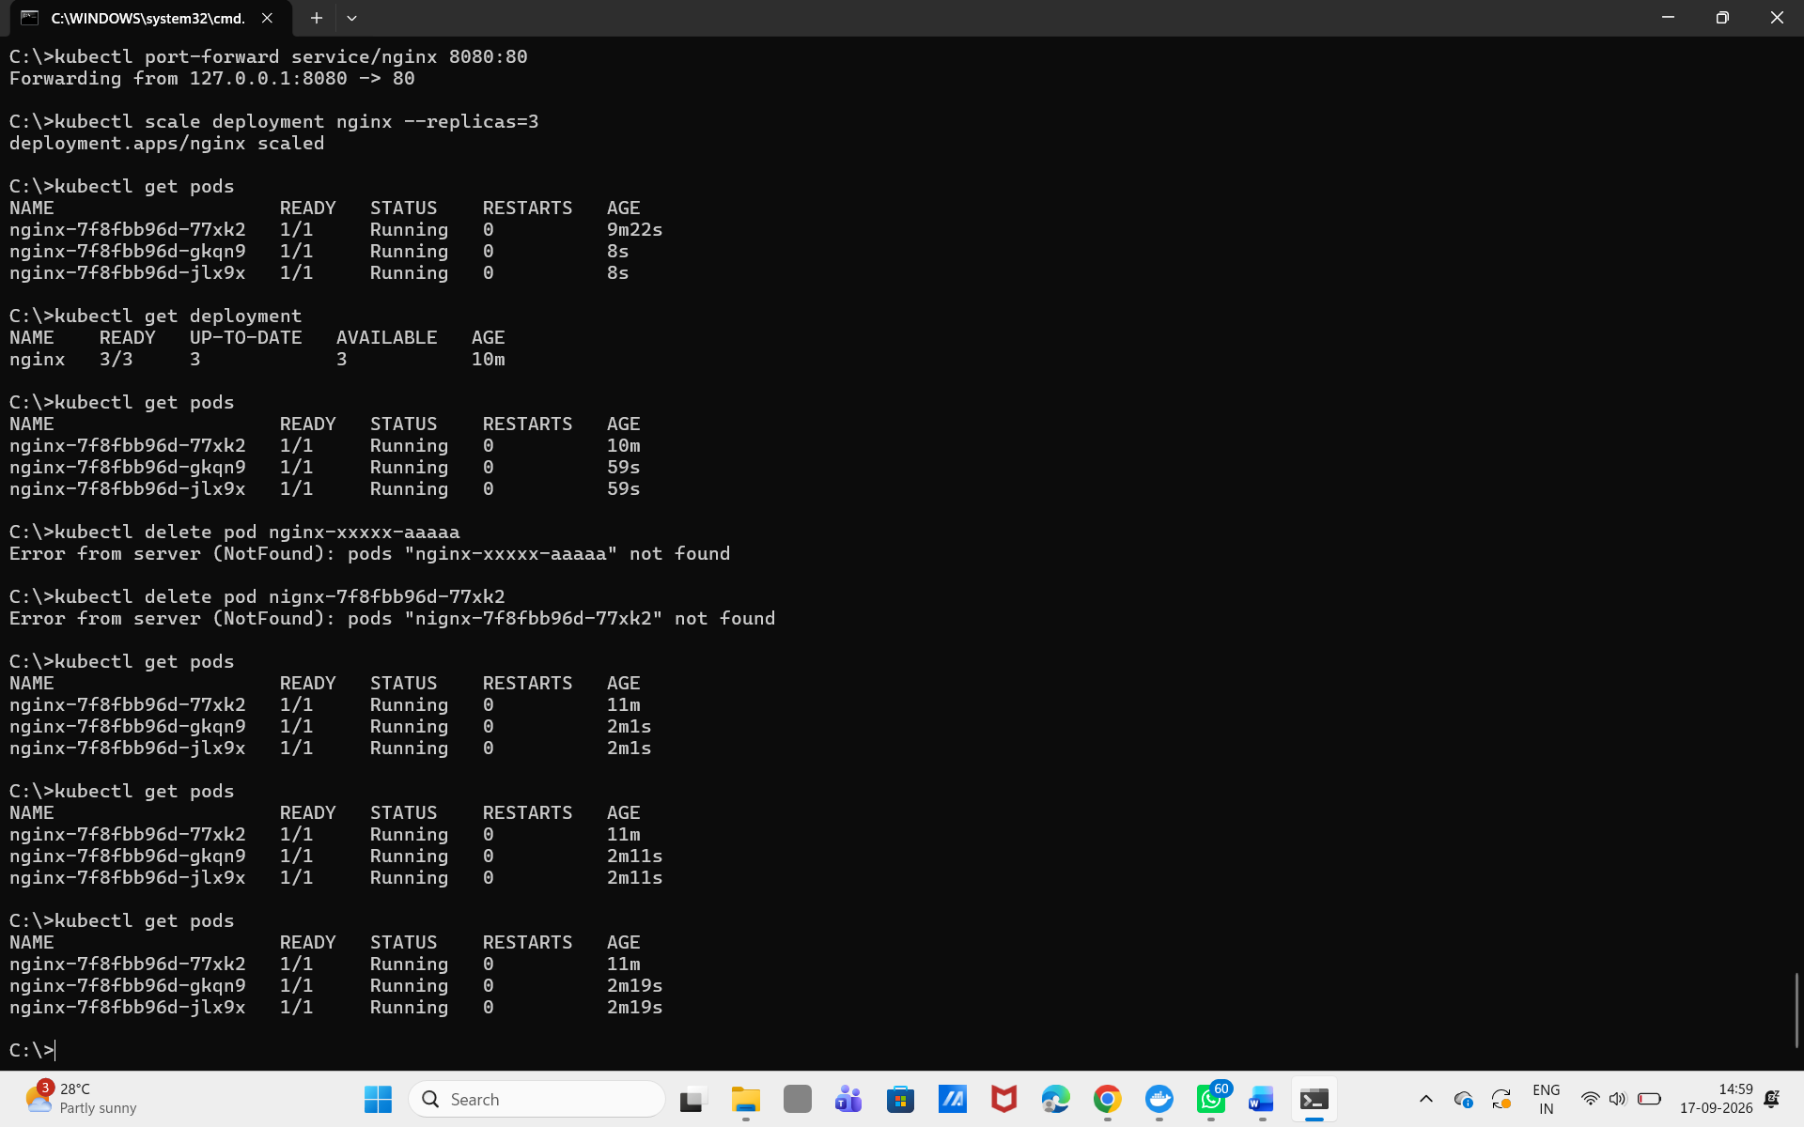 📷 INSERT SCREENSHOT HERE
Before / after: `kubectl get pods` showing the replacement Pod

Part T — View everything together

Step T1: List all resources
This one command is very useful for beginners — it shows Pods, Services, Deployments, and ReplicaSets in one place.
Run:
kubectl get all

Expected output:
pod/...
pod/...
pod/...

service/nginx

deployment.apps/nginx

replicaset.apps/nginx

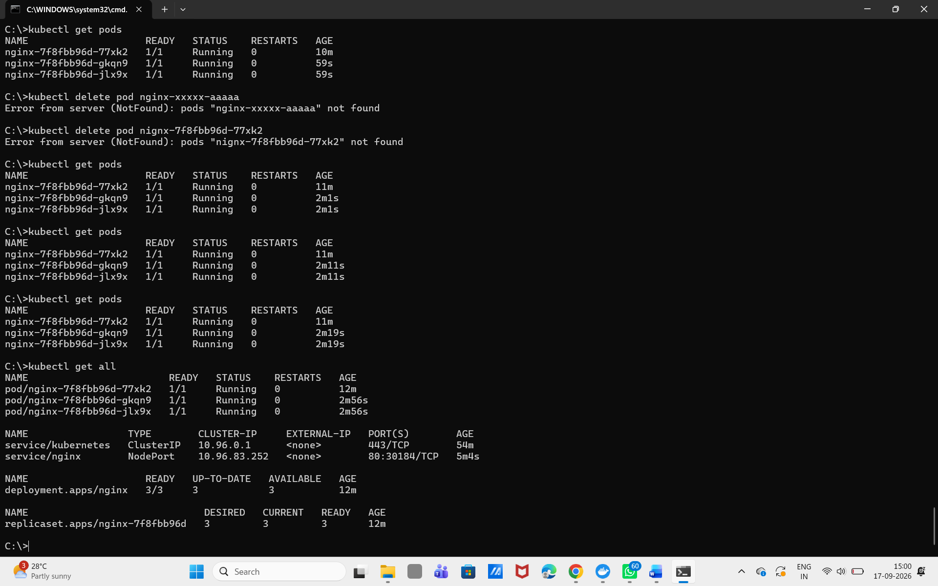 📷 INSERT SCREENSHOT HERE
Full output of `kubectl get all`

Part U — Understand ReplicaSet
You didn't directly create a ReplicaSet — but when you created the Deployment, Kubernetes created one automatically.
Deployment
|
v
ReplicaSet
|
+---------+---------+
| | |
v v v
Pod Pod Pod
Deployment manages the ReplicaSet, and the ReplicaSet manages the desired number of Pods.

Part V — Inspect the Service

Step V1: Describe the Service
Run:
kubectl describe service nginx

Expected output:
Type: NodePort
Port: 80
TargetPort: 80
Endpoints: ...

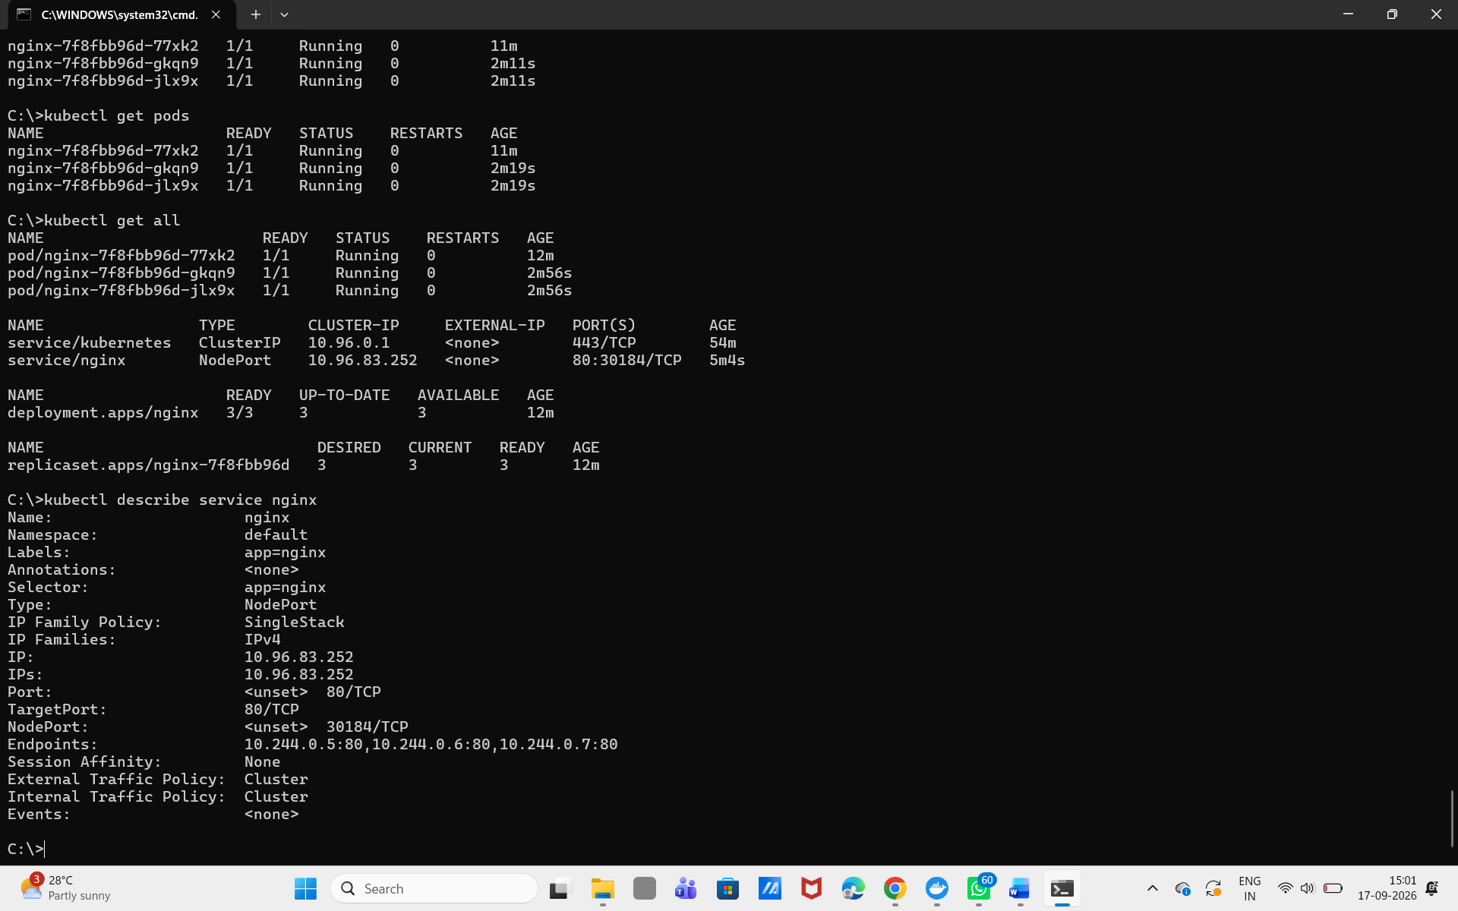 📷 INSERT SCREENSHOT HERE
Relevant section of `kubectl describe service nginx` output

Think of the traffic flow as:
Service
|
| port 80
v
Pods
|
| port 80
v
Nginx

Part W — Clean up
When your practical is complete, remove the resources you created.

Step W1: Delete the Service
Run:
kubectl delete service nginx

Step W2: Delete the Deployment
Run:
kubectl delete deployment nginx

Step W3: Confirm everything is gone
Run:
kubectl get all

Expected output:
(your nginx resources should no longer appear)

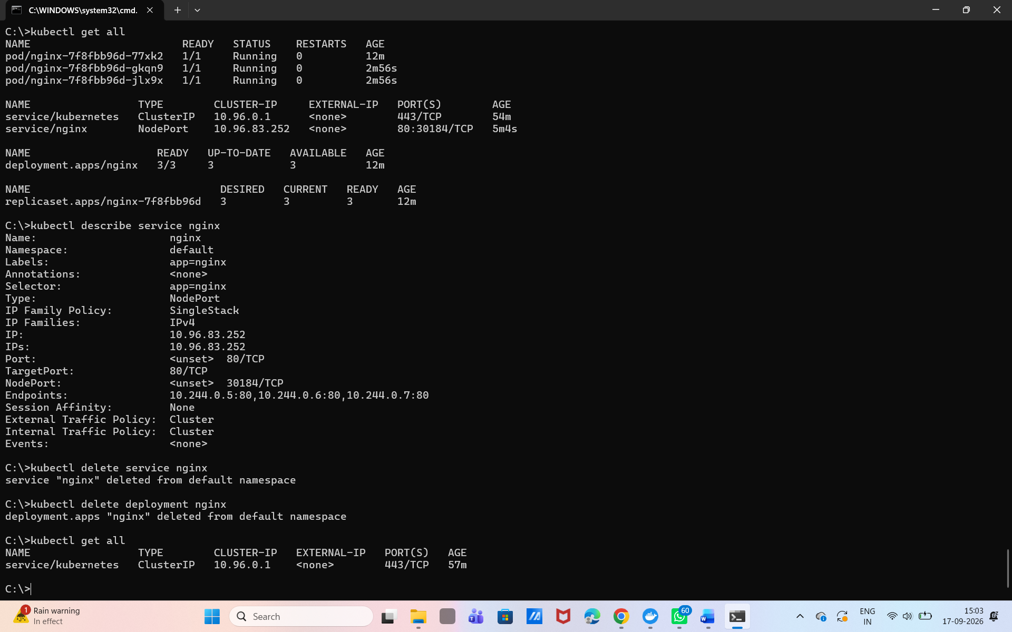 📷 INSERT SCREENSHOT HERE
Final `kubectl get all` showing a clean cluster

What you should understand after Practical 1
Concept | Simple meaning
Docker Image | Blueprint for a container
Container | Running instance of an image
Kubernetes Cluster | Kubernetes environment
Node | Machine running Kubernetes workloads
Pod | Smallest deployable Kubernetes unit
Deployment | Manages application Pods
ReplicaSet | Maintains desired number of Pods
Service | Provides stable network access to Pods
NodePort | Exposes a Service through a node port
Scaling | Increasing/decreasing number of Pods
Self-healing | Kubernetes recreates failed/deleted Pods

Appendix — Full command list (lab notebook copy)
docker --version
docker pull nginx
docker run -d --name my-nginx -p 8080:80 nginx
docker ps
docker stop my-nginx
docker rm my-nginx
kubectl get nodes
kubectl create deployment nginx --image=nginx
kubectl get deployments
kubectl get pods
kubectl get pods -o wide
kubectl describe pod <POD_NAME>
kubectl logs <POD_NAME>
kubectl expose deployment nginx --type=NodePort --port=80
kubectl get services
kubectl port-forward service/nginx 8080:80
kubectl scale deployment nginx --replicas=3
kubectl get pods
kubectl get deployment
kubectl delete pod <POD_NAME>
kubectl get pods
kubectl get all
kubectl delete service nginx
kubectl delete deployment nginx

Submission checklist
☐ Screenshot: docker ps output (Part A)
☐ Screenshot: kubectl get nodes showing Ready (Part C)
☐ Screenshot: Docker Desktop Kubernetes settings (Part B)
☐ Screenshot: docker images showing nginx:latest (Part E)
☐ Screenshot: browser showing Nginx via Docker, localhost:8080 (Part F)
☐ Screenshot: kubectl create deployment confirmation (Part H)
☐ Screenshot: kubectl get pods showing Running (Part J)
☐ Screenshot: kubectl describe pod output (Part L)
☐ Screenshot: kubectl get services showing NodePort (Part O)
☐ Screenshot: browser showing Nginx via Kubernetes Service (Part P)
☐ Screenshot: kubectl get pods showing 3 replicas (Part Q)
☐ Screenshot: self-healing before/after (Part S)
☐ Screenshot: kubectl get all (Part T)
☐ Screenshot: kubectl describe service nginx (Part V)
☐ Screenshot: final kubectl get all after cleanup (Part W)
☐ Short reflection: in your own words, explain the difference between a Deployment, a Pod, and a Service.

